Document History
Document Name | Detail | Status | Date | View able | Reviewer& Responsible
HanDIYcraft-Project Plan-0.1.docx | -Introduction  -Schedule and Milestones | Draft | 8/4/14 | Advisor | NK, PS
HanDIYcraft -Project Plan-0.2.docx | -Update Introduction  -Infrastructure  -Quality Planning  -Estimated Effort and Costs  -Version Control Strategy | Draft | 9/4/14 | Advisor | NK, PS
HanDIYcraft -Project Plan-0.3.docx | -Update Infrastructure  -Management Procedures  -Estimate Duration of Tasks | Draft | 11/4/14 | Advisor | NK, PS
HanDIYcraft -Project Plan-0.4.docx | -Update Quality Planning  -Identification of Project Risks | Draft | 12/4/14 | Advisor | NK, PS
HanDIYcraft -Project Plan-0.5.docx | -Appendix | Draft | 14/4/14 | Advisor | NK, PS
HanDIYcraft -Project Plan-1.0.docx | -Update Appendix | Release | 7/7/14 | Advisor | NK, PS
HanDIYcraft -Project Plan-1.1.docx | -Update Introduction | Release | 21/7/14 | Advisor | NK, PS
HanDIYcraft -Project Plan-1.2.docx | -Update Estimate Duration of Tasks | Draft | 20/10/14 | Advisor | NK, PS
HanDIYcraft -Project Plan-2.0.docx | -Update Estimate Duration of Tasks | Release | 21/10/14 | Advisor | NK, PS
HanDIYcraft -Project Plan-3.0.docx | -Update Estimate Duration of Tasks  -Appendix | Release | 10/12/14 | Advisor | NK, PS
NK : Nahathai Kaewtatib
PS : Pimchanok Sripraphan

…………………………
Ms. Nahathai Kaewtatib
Project Plan Writer

…………………………
Ms. Pimchanok Sripraphan
Project Plan Writer

11th December 2014

Table of Contents
Chapter One| Introduction 4
1.1 Project Overview 4
1.1.1 Purpose 4
1.1.2 Scope 4
1.1.3 Acronyms and Definitions 6
1.2 Work Product to be developed 7
1.2.1 Deliverables 7
1.2.2 Non-Deliverables 8
Chapter Two | Infrastructure 9
2.1 Hardware/Software Acquisition 9
2.1.1 Hardware 9
2.1.2 Software Acquisition 9
2.2 Project Specific System Administration Support Needed 9
2.2.1 Software needed 9
Chapter Three | Management Procedures 10
3.1 Project team structure 10
3.2 Monitoring and Controlling Mechanisms 10
3.2.1 Software Development Model 10
3.2.2 Status Reporting 11
3.2.3 Project Meeting 12
3.3 Change Management 13
Chapter Four | Quality Planning 13
4.1 Quality Factors 13
4.1.1 Product Operation Factors 13
4.1.2 Product Revision Factors 13
4.1.3 Product Transition Factors 13
4.2 Reviews and Responsibility 14
4.3 Testing 14
4.4 Software Development Standard 15
4.4.1 ISO92110 for Very Small Entity (VSE) 15
4.4.2 Project Management (PM) process 15
4.4.3 Software Implementation (SI) process 16
Chapter Five | Estimated Duration of Tasks 18
Chapter Six | Estimated Effect and Costs 22
Chapter Seven | Identification of Project Risks 23
Chapter Eight | Version Control Strategy 24
8.1 Naming Conversion 24
8.2 Project Repository 24
8.3 Configuration Item Table 25
Chapter Nine | Schedule and Milestones 26
Chapter Ten | Appendix 31
Chapter One | Introduction

Our project is a project from SE499 (Senior Project), which consists of two members. The project is about DIY tutorials that will be provided as both mobile and web application. This project plan document presents the way we will manage a software project through times. Also, explains the detail of each process from the initialing to the closing one.
1.1 Project Overview
HanDIYcraft is a web application and mobile application for smartphone that supports Android operating system. It is an application that guide users the method how to turn their old things, into a new one by themselves. This application provides several tutorials for users to learn. Moreover, in case the users do not have the needed materials and have no idea where to buy, this application provides a feature to let the users check out the shops that sell related materials for making their DIY artworks. Apart from just exploring, the users can also directly communicate with the shopkeepers by sending private messages.
    - Purpose
- Open up DIY ideas for the users and bloggers.
- Let shopkeepers advertise their shops.
- Help bloggers find the places where they could get the materials they want by Map feature.
- Let bloggers communicate among themselves and with the shopkeepers.

    - Scope

Main features of HanDIYcraft are listed as follows:

Feature 1: User's Profile and Authorization Management
- Develop register, log in, and log out system for bloggers. (On both web and mobile)
- Develop register, log in, and log out system for shopkeepers. (On mobile)
- Display blogger's profile which contain profile picture, username, email, number of following and follower people, and created tutorials, and let the him/her edit their information.
- Display shopkeeper's profile, which contain profile picture, username, email, and created shops, and let him/her edit their information.

Feature 2: Tutorial Management (On both web and mobile)
- Add a tutorial which contain pictures, descriptions, and a video by blogger.
- Manage(edit/delete) tutorials by blogger.
- Search tutorials title by keyword.
- Display tutorials that exist in the database by random, popular, and following.
- Display tutorial's detail, which contain tutorial owner username, number of likes, tutorial title, pictures, material, descriptions, a video, and comments.

Feature 3: Shop Management (On Mobile)
- Add a shop which contain pictures, descriptions, and a video by shopkeeper.
- Manage(edit/delete) shops by shopkeeper.
- Search shop name by keyword.
- Display shops that exist in the database randomly.
- Display shop's detail, which contain shop name, shop owner username, branch, telephone number, information, shop's pictures, and location.

Feature 4: Map Management (On Mobile)
- See the shop's location via Google Maps.
- See shops’ location near by the user via Google Maps.
- Pin shop's location via Google Maps by shopkeeper.

Feature 5: Communication Management (On Mobile)
- See and add comments on tutorials by blogger
- Communicate via private messages
- Search bloggers by username by shopkeeper.
- Giving and undo likes on tutorials by blogger.
- Follow and unfollow bloggers by blogger.
- See list of follower and following bloggers.
- Share tutorials to Facebook

Feature 6: The system provides notifications. (On Mobile)
- Display list of news when there is new tutorial comment, tutorial like, or follower.
- Display a sign when there is a new message.

Non-functional features:
- Available only in English.
- Provide attractive and unique Graphic User Interface.
- Provide understandable symbols and language.
- Easy for the new user to learn the system.
- Give correct and accurate result.
- Authorization is supported.
- Does not display any religious neither symbols nor words.

1.1.3 Acronyms and Definitions
- Acronyms
PMP = Project Management Plan
SDD = Software Design Document
SRS = Software Requirement Specification
SW = Siraprapa Wattanakul
NK = Nahathai Kaewtatib
PS = Pimchanok Sripraphan

1.2 Work Product to be developed

1.2.1 Deliverables
No. | Deliverables/Release | Media | No. of Copies | Date
1 | Project Proposal  - HanDIYcraft Proposal version 1.0 | Hard Copy | 4 | 5/4/2014
2 | The Progress Report I  - Project Management Plan version 1.0  - Software Requirement Specification version 1.0  - Software Design Document version 1.0  - Test Plan version 1.0  - Traceability Record version 1.0 | Hard Copy | 3 | 7/7/2014
3 | The Progress Report II  - Project Management Plan version 2.0  - Software Requirement Specification version 2.0  - Software Design Document version 2.0  - Test Plan version 2.0  - Traceability Record version 2.0 | Hard Copy | 3 | 3/9/2014
4 | The Progress Report III (Show Pro)  - Project Management Plan version 3.0  - Software Requirement Specification version 3.0  - Software Design Document version 3.0  - Test Plan version 3.0  - Traceability Record version 3.0 | Hard Copy | 3 | 5/11/2014
5 | The Final Progress Report  - Project Management Plan version 4.0  - Software Requirement Specification version 4.0  - Software Design Document version 4.0  - Test Plan version 4.0  - Traceability Record version 4.0 | Hard Copy | 3 | 26/11/2014
6 | - Software Source code version 1.0 | Software | 1 | 26/11/2014

    - Non-Deliverables

No. | Work Products | Media
1 | 30 seconds video presentation | File
2 | 5 minutes video presentation | File
3 | Poster presentation | Poster

Chapter Two | Infrastructure

  - Hardware/Software Acquisition Plans
    - Hardware
- Computer
The computer would be the main tool to run Eclipse IDE in order to develop our Android application.

- Smartphone
An Android smart phone will be used in testing the application. The device should supports Google Maps too. Android OS version 4.2 or later is required.

    - Software Acquisition Plans
- Server
Server is used as data storage. It will store the necessary file such as PHP file, information, pictures and more.
- Eclipse
- Android SDK
- MySQL Server
- Web Server

  - Project Specific System Administration Support Needed
    - Software needed
- GitHub
- Gantt Chart
- Visual Paradigm for UML
- Photoshop
- Microsoft Word
- Microsoft PowerPoint
- Microsoft Excel

Chapter Three |
Management Procedure

  - Project Team Structure
Project Team Members:
- Ms. Nahathai Kaewtatib 542115018
- Ms. Pimchanok Sripraphan 542115043
Responsibility | Owner | Reviewer
Project Proposal | PS | NK
Project Plan and Quality Plan | PS | NK
Requirement Specification | PS | NK
Design Document | PS | NK
Implementation | PS | NK
Traceability Record | PS | NK
Testing Record | PS | NK

  - Monitoring and Controlling Mechanisms
    - Software Development Model
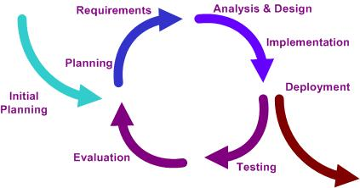

Iterative Model is a popular software development life cycle model that is used in software development process. It starts with a simple implementation of a small set of the software requirements, and iteratively increase it until the whole system is complete and ready to be deployed.

No. | Progress Report | Software Items | Date
1 | Project Proposal Report | - Proposal | 5/4/2014
2 | 1st Progress Report | - Project Management Plan  - Software Requirement Specification  - Software Design Document  - Implemented Software Progress I  - Test Plan  - Traceability Record | 7/7/2014
3 | 2nd Progress Report | - Project Management Plan  - Software Requirement Specification  - Software Design Document  - Implemented Software Progress II  - Test Plan  - Traceability Record | 22/10/2014
4 | 3rd Progress Report (Show Pro) | - Project Management Plan  - Software Requirement Specification  - Software Design Document  - Implemented Software Progress III  - Test Plan  - Traceability Record | 19/11/2014
5 | Final Progress Report | - Project Management Plan  - Software Requirement Specification  - Software Design Document  - Complete Software Source code  - Test Plan  - Traceability Record | 11/12/2014
    - Status Reporting

    - Project Meeting

  - Change Management
Change Management manages and controls all of the changes that happen during the project development process. The change requests will be recorded into the change management document.

Here are the steps of our strategy for change management:
- Analyze the change request (How necessary it is and the impact to the other part of the system).
- Set a change request form.
- Approve the change request by the project advisor.
4. Change the project according to the approved change request.

No. | Participants | Roles
1 | Ms. Siraprapa Wattanakul | Project advisor
2 | Ms. Nahathai Kaewtatib | Development team member
3 | Ms. Pimchanok Sripraphan | Development team member

Chapter Four | Quality Planning

  - Quality Factors
HanDIYcraft software should meet these quality factors according to the McCall’s Model.

    - Product Operation Factors
Correctness
The software should provide more than 80% of data as the user requested correctly.
Usability
The software should provide understandable and easy-to-use GUI and language.
Reliability
The software should perform with more than 80% of usual activities, and with less than 10% of failure.
Integrity
The software should be able to identify between authorized and unauthorized users, and also between each type of users.

    - Product Revision Factors
Maintainability
The software should contain 20-30% of comments from the total LOC, in order to support further more maintenance.
Testability
The software should be 100% tested.

    - Product Transition Factors
Reusability
More than 50% of the complete software should be able to be reused in the future.

  - Reviews and Responsibility
Stage Exit Review
No. | Stage | Software Items | Owner | Reviewer
1 | 1st Progress | Project Management Plan | PS | NK
2 | 1st Progress | Software Requirement Specification | PS | NK
3 | 1st Progress | Software Design Document | PS | NK
4 | 1st Progress | Test Plan | PS | NK
5 | 1st Progress | Traceability Record | PS | NK
6 | 2nd Progress | Project Management Plan | PS | NK
7 | 2nd Progress | Software Requirement Specification | PS | NK
8 | 2nd Progress | Software Design Document | PS | NK
9 | 2nd Progress | Test Plan | PS | NK
10 | 2nd Progress | Traceability Record | PS | NK
11 | 3rd Progress | Project Management Plan | PS | NK
12 | 3rd Progress | Software Requirement Specification | PS | NK
13 | 3rd Progress | Software Design Document | PS | NK
14 | 3rd Progress | Test Plan | PS | NK
15 | 3rd Progress | Traceability Record | PS | NK

  - Testing

Test Process
No. | Test | Responsibility
1 | Unit Test | NK, PS
2 | System Test | NK, PS
3 | Acceptance Test | NK, PS

  - Software Development Standard

4.4.1 ISO29110 for Very Small Entity (VSE)
ISO29110 is a guide applies to a Very Small Entity (VSE), enterprise, organization, department or project up to 25 people, dedicated to software development. The Guide provides Project Management and Software Implementation processes which integrate practices based on the selection of ISO/IEC 12207- Systems and Software Engineering — Software Life Cycle Processes and ISO/IEC 15289Software Engineering – Software Life Cycle Process – guidelines for the content of software life cycle process information products (documentation) standards elements.

4.4.2 Project Management (PM) process
PM Purpose
The purpose of the Project Management process is to establish and carry out in a systematic way the tasks of the software implementation project, which allows complying with the project’s objectives in the expected quality, time and costs.
PM objectives
PM.O1. The Project Plan for the execution of the project is developed according to the Statement of Work and validated with the Customer. The tasks and resources necessary to complete the work are sized and estimated.
PM.O2. Progress of the project is monitored against the Project Plan and recorded in the Progress Status Record. Corrections to remediate problems and deviations from the plan are taken when project targets are not achieved. . Appropriate treatment is taken to correct or avoid the impact of risk. Closure of the project is performed to get the Customer acceptance documented in the Acceptance Record.
PM.O3. The Change Requests are addressed through their reception and analysis. Changes to software requirements are evaluated for cost, schedule and technical impact.
PM.O4. Review meetings with the Work Team and the Customer are held. Agreements are registered and tracked.
PM.O5. Risks are identified as they develop and during the conduct of the project.
PM.O6. A software Version Control Strategy is developed. Items of Software Configuration are identified, defined and baselined. Modifications and releases of the items are controlled and made available to the Customer and Work Team including the storage, handling and delivery of the items.
PM.O7. Software Quality Assurance is performed to provide assurance that work products and processes comply with the Project Plan and Requirements Specification.
PM Activities
The Project Management Process has the following activities:
- - PM.1 Project Planning
- - PM.2 Project Plan Execution
- - PM.3 Project Assessment and Control
- - PM.4 Project Closure

4.4.3 Software Implementation (SI) process
SI purpose
The purpose of the Software Implementation process is the systematic performance of the analysis, design, construction, integration and tests activities for new or modified software products according to the specified requirements.
SI objectives
SI.O1. Tasks of the activities are performed through the accomplishment of the current Project Plan.
SI.O2. Software requirements are defined, analyzed for correctness and testability, approved by the Customer, baselined and communicated.
SI.O3. Software architectural and detailed design is developed and baselined. It describes the software items and internal and external interfaces of them. Consistency and traceability to software requirements are established.
SI.O4. Software components defined by the design are produced. Unit test are defined and performed to verify the consistency with requirements and the design. Traceability to the requirements and design are established.
SI.O5. Software is produced performing integration of software components and verified using Test Cases and Test Procedures. Results are recorded at the Test Report. Defects are corrected and consistency and traceability to Software Design are established.

SI.O6. A Software Configuration, that meets the Requirements Specification as agreed to with the Customer, which includes user, operation and maintenance documentations is integrated, baselined and stored at the Project Repository. Needs for changes to the Software Configuration are detected and related Change Requests are initiated.
SI.O7. Verification and Validation tasks of all required work products are performed using the defined criteria to achieve consistency among output and input products in each activity. Defects are identified, and corrected; records are stored in the Verification/Validation Results.
SI activities
The Software Implementation Process has the following activities:
- - SI.1 Software Implementation Initiation
- - SI.2 Software Requirements Analysis
- - SI.3 Software Architectural and Detailed Design
- - SI.4 Software Construction
- - SI.5 Software Integration and Tests
- - SI.6 Product Delivery

Chapter Five |
Estimated Duration of Tasks

Feature 1: User’s Profile and Authorization Management
Feature 2: Tutorial Management
Feature 3: Shop Management
Feature 4: Map Management
Feature 5: Communication Management
Feature 6: Notification management

Task Name | Duration  (in days) | Begin Date | End Date
Project Management Plan | 7 | 8/4/2014 | 14/4/2014
Software Requirement Specification | 7 | 15/4/2014 | 21/4/2014
Software Design  - Use Case Diagram  - Activity Diagram  - Class Diagram  - Sequence Diagram  - ER Diagram  - UI Design | 15 | 22/4/2014 | 6/5/2014
1st Progress Implementation | 40 | 7/5/2014 | 20/6/2014
1st Progress Testing Document  - Test Plan  - Test Record | 10 | 21/6/2014 | 30/6/2014
1st Progress Traceability Record | 5 | 1/7/2014 | 5/7/2014
1st Progress Submission | 1 | 7/7/2014 | 7/7/2014
1st Progress Presentation | 2 | 10/7/2014 | 11/7/2014
Progress I

Progress II

Task Name | Duration  (in days) | Begin Date | End Date
Project Management Plan | 3 | 13/7/2014 | 15/7/2014
Software Requirement Specification | 5 | 16/7/2014 | 20/7/2014
Software Design  - Use Case Diagram  - Activity Diagram  - Class Diagram  - Sequence Diagram  - ER Diagram  - UI Design | 10 | 21/7/2014 | 30/7/2014
2nd Progress Implementation | 25 | 31/7/2014 | 24/8/2014
2nd Progress Testing Document  - Test Plan  - Test Record | 5 | 25/8/2014 | 29/8/2014
2nd Progress Traceability Record | 2 | 30/8/2014 | 31/8/2014
2nd Progress Submission | 1 | 22/10/2014 | 22/10/2014
2nd Progress Presentation | 2 | 29/10/2014 | 30/10/2014

Progress III (Show Pro)
Task Name | Duration  (in days) | Begin Date | End Date
Project Management Plan | 1 | 2/11/2014 | 2/11/2014
Software Requirement Specification | 6 | 3/11/2014 | 6/11/2014
Software Design  - Use Case Diagram  - Activity Diagram  - Class Diagram  - Sequence Diagram  - ER Diagram  - UI Design | 4 | 7/11/2014 | 11/11/2014
3rd Progress Implementation | 6 | 12/11/2014 | 17/11/2014
3rd Progress Testing Document  - Test Plan  - Test Record | 2 | 17/11/2014 | 18/11/2014
3rd Progress Traceability Record | 1 | 18/11/2014 | 18/11/2014
3rd Progress Submission | 1 | 19/11/2014 | 19/11/2014
3rd Progress Presentation | 1 | 19/11/2014 | 19/11/2014

Task Name | Duration  (in days) | Begin Date | End Date
Documentation  - Overall Software Specification  - Overall Software Design  - Overall Traceability Record  - Overall Testing  - Binding Document | 8 | 21/11/2014 | 28/11/2014
Software Source code | 8 | 29/11/2014 | 6/12/2014
Release Software | 1 | 7/12/2014 | 7/12/2014
Advertise Software to Media | 2 | 8/12/2014 | 9/12/2014
Final Progress Submission | 1 | 11/12/2014 | 11/12/2014
Final Progress Presentation | 2 | 17/12/2014 | 18/12/2014

Final Progress

Chapter Six |
Estimated Effort and Costs
Item | Approximately Cost (THB)
Text Books | 1,000
Android Device for testing the system | 5,000
Document Printing | 2,000
Poster Presentation | 500

Chapter Seven |
Identification of Project Risks
Risk | Likelihood/Impact | Mitigation
Time Management | High/High | Catch up the Schedule and Milestones
Less skills, knowledge, and experience | High/High | - Search the information from the Internet  - Ask from the experienced developers.
Dealing with changes | High/High | Use the change management strategy
Unfamiliar with the testing process | Medium/Medium | Study more about the testing process
Hardware crash | Medium/High | Always save the documents and source code into the repository (GitHub)

Chapter Eight |
Version Control Strategy

  - Naming Conversion
The file naming format that we are going to use for all project documents is
“[Project Name]-[Document Name]-[Version]”

  - Project Repository
GitHub provides users free spaces to easily store and share their photos, documents, information, and even source code. It is like a social network for the programmers.

Figure 1.6: Project Repository

List of related document and description
- Proposal: contains involved proposal document files
- Project Plan: contains project plan document files
- SRS: contains software requirement specifications document files
- Design: contains design document files
- Test: contains testing document files
- Traceability Record: contains traceability record files
- Presentation: contains presentation files
- Source Code: contains source code of the project
- GUI: contains the pictures that will be used as Graphic User Interface of the system.
- Others: contain pictures, involved and interesting information, etc.

  - Configuration Item Table
No. | Item | File Name | File Type | Owner | Path | Baseline Version
1 | Project Proposal | HanDIYcraft-Proposal-V.[version] | .docx | NK, PS | /HanDIYcraft/Proposal | 1.0
2 | Project Management Plan | HanDIYcraft-ProjectPlan-V.[version] | .docx | NK, PS | /HanDIYcraft/Project Plan | 2.0
3 | Software Requirement Specification | HanDIYcraft-SRS-V.[version] | .docx | NK, PS | /HanDIYcraft/SRS | 2.0
4 | Software Design Document | HanDIYcraft-SDD-V.[version] | .docx | NK, PS | /HanDIYcraft/Design | 2.0
5 | Test Plan | HanDIYcraft-TestPlan-V.[version] | .docx | NK, PS | /HanDIYcraft/Test | 2.0
6 | Test Record | HanDIYcraft-TestRecord-V.[version] | .docx | NK, PS | /HanDIYcraft/Test | 2.0
7 | Traceability Record | HanDIYcraft-TR-V.[version] | .docx | NK, PS | /HanDIYcraft/Traceability Record | 2.0

Chapter Nine |
Schedule and Milestones

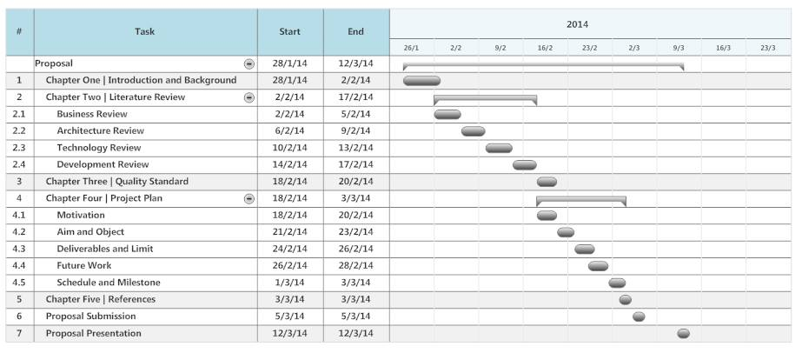

Figure 1.6: The Milestone of Initial Project

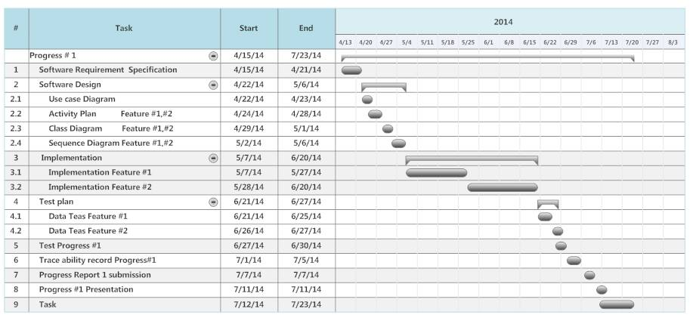

Figure 1.7: The Milestone of First Progress Report

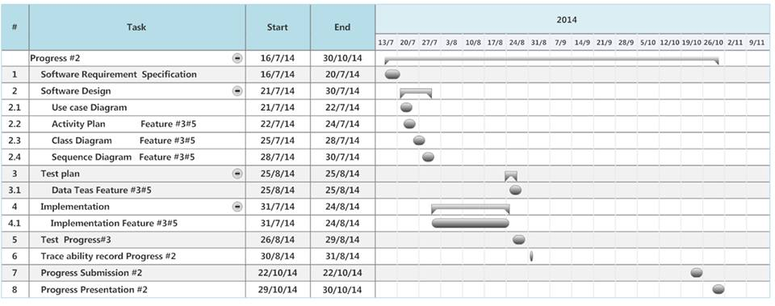

Figure 1.8: The Milestone of Second Progress Report

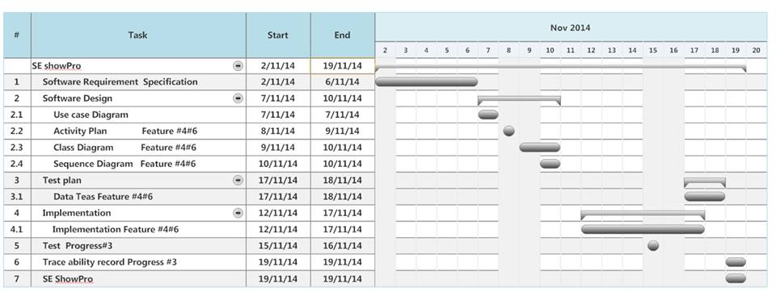

Figure 1.9: The Milestone of Show Pro Progress Report

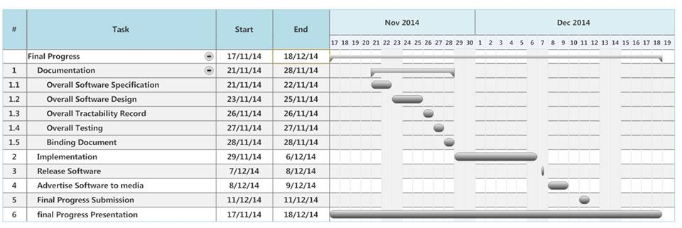

Figure 1.10: The Milestone of Final Progress Report
Chapter Ten | Appendix

Attribute Rating
Process attribute rating values: The ordinal rating scale defined below shall be used to express the levels of achievement of the process attributes.
-  N Not achieved: There is little or no evidence of achievement of the defined attribute in the assessed process.
-  P Partially achieved: There is some evidence of an approach to, and some achievement of, the defined attribute in the assessed process. Some aspects of achievement of the attribute may be unpredictable.
-  L Largely achieved: There is evidence of a systematic approach to, and significant achievement of, the defined attribute in the assessed process. Some weakness related to this attribute may exist in the assessed process.
-  F Fully achieved: There is evidence of a complete and systematic approach to, and full achievement of, the defined attribute in the assessed process. No significant weaknesses related to this attribute exist in the assessed process.

Project Management (PM) Process PM purpose
The purpose of the Project Management process is to establish and carry out in a systematic way the tasks of the software implementation project, which allows complying with the project’s objectives in the expected quality, time and costs.
Objective | Description | Rating Result
PM.O1 | The Project Plan for the execution of the project is developed according to the Statement of Work and validated with the Customer. The tasks and resources necessary to complete the work are sized and estimated. | L
PM.O2 | Progress of the project is monitored against the Project Plan and recorded in the Progress Status Record. Corrections to remediate problems and deviations from the plan are taken when project targets are not achieved. Appropriate treatment is taken to correct or avoid the impact of risk. Closure of the project is performed to get the Customer acceptance documented in the Acceptance Record. | L
PM.O3 | The Change Requests are addressed through their reception and analysis. Changes to software requirements are evaluated for cost, schedule and technical impact. | L
PM.O4 | Review meetings with the Work Team and the Customer are held. Agreements are registered and tracked. | P
PM.O5 | Risks are identified as they develop and during the conduct of the project. | P
PM.O6 | A software Version Control Strategy is developed. Items of Software Configuration are identified, defined and baselined. Modifications and releases of the items are controlled and made available to the Customer and Work Team including the storage, handling and delivery of the items. | L
PM.O7 | Software Quality Assurance is performed to provide assurance that work products and processes comply with the Project Plan and Requirements Specification. | L

Task lists for PM. Process
PM.1 Project planning, (PM.O1, PM.O5, PM.O6, PM.O7)
Role | Task List | Evidence  (item name/page/topic) | Rating Result
PM, TL | PM.1.1 Review the Statement of Work | HanDIYcraft-ProjectPlan-V.2.0/14/Reviews and Responsibility | L
PM, CUS | PM.1.2 Define with the Customer the Delivery Instructions of each one of the deliverables specified in the Statement of Work. | HanDIYcraft-ProjectPlan-V.2.0/26/Schedule and Milestone | L
PM, TL | PM.1.3 Identify the specific tasks to be performed in order to produce the deliverables and their software components identified in the Statement of Work. Include verification, validation and reviews with Customer and Work Team tasks to assure the quality of work products. Identify the tasks to perform the Delivery Instructions. Document the Tasks. | HanDIYcraft-ProjectPlan-V.2.0/7/Work product to be developed | L
PM, TL | PM.1.4 Establish the Estimated Duration to perform each task. | HanDIYcraft-ProjectPlan-V.2.0/18/Estimated Duration of Tasks | L
PM, TL | PM.1.5 Identify and document the resources: human, material, equipment and tools, including the required training of the Work Team to perform the project. Include in the schedule the dates when resources and training will be needed. | HanDIYcraft-ProjectPlan-V.2.0/9/Infrastructure | P
PM, TL | PM.1.6 Establish the Composition of Work Team assigning roles and responsibilities according to the Resources. | HanDIYcraft-ProjectPlan-V.2.0/14/Reviews and Responsibility | P
PM, TL | PM.1.7 Assign estimated start and completion dates to each one of the tasks in order to create the Schedule of the Project Tasks taking into account the assigned resources, sequence and dependency of the tasks. | HanDIYcraft-ProjectPlan-V.2.0/18/Estimated Duration of Tasks  HanDIYcraft-ProjectPlan-V.2.0/26/Schedule and Milestone | L
PM, TL | PM.1.8 Calculate and document the project Estimated Effort and Cost. | HanDIYcraft-ProjectPlan-V.2.0/22/Estimated Effort and Cost | P
PM, TL | PM.1.9 Identify and document the risks which may affect the project. | HanDIYcraft-ProjectPlan-V.2.0/23/Identify of Project Risk | P
PM, TL | PM.1.10 Document the Version Control Strategy in the Project Plan. | HanDIYcraft-ProjectPlan-V.2.0/24/Version Control Strategy | L
PM, TL | PM.1.11 Generate the Project Plan or update it. Furthermore, the Project Plan can be updated due to the Change Request made by the Customer or arising from the project. | HanDIYcraft-ProjectPlan-V.2.0/1/Document History | L
PM, TL | PM.1.12 Include product description, scope, objectives and deliverables in the Project Plan. | HanDIYcraft-ProjectPlan-V.2.0/4/Introduction | L
PM, TL | PM.1.13 Verification of the Project Plan. Verify that all Project Plan elements are viable and consistent. The results found are documented in a Verification Results and corrections are made until the document is approved by TL. | - | N
PM, CUS | PM.1.14 Validation of the Project Plan.  Validate that the Project Plan elements definition match with the Statement of Work. The results found are documented in a Validation Results and corrections are made until the document is approved by CUS. | - | N
PM, TL | PM.1.15 Establish or prepare the project repository using the Version Control Strategy. | HanDIYcraft-ProjectPlan-V.2.0/24/Version Control Strategy | L

PM.2 Project plan execution (PM.O2, PM.O3, PM.O4, PM.O5, PM.O7)
Role | Task List | Evidence  (item name/page/topic) | Rating Result
PM, TL, WT | PM.2.1 Review the Project Plan and record actual data in Progress Status Record. | HanDIYcraft-ProjectPlan-V.2.0/11/Status Reporting | L
PM, TL | PM.2.2 Analyze and evaluate the Change Request for cost, schedule and technical impact, and include the accepted changes in the Project Plan.  The Change Request can be initiated externally by the Customer or internally by the Work Team.  The evaluation of Change Request initiated by Customer or those which affects the Customer needs. Negotiate with Customer to obtain its acceptance (see PM.2.4). | HanDIYcraft-ProjectPlan-V.2.0/12/Change Management | P
PM, TL, WT | PM.2.3 Conduct revision meetings with the Work Team, review risk status, record agreements and track them to closure. | HanDIYcraft-ProjectPlan-V.2.0/24/Project Meeting | P
PM, CUS, TL, WT | PM.2.4 Conduct revision meetings with the Customer, record agreements and track them to closure.  Change Request initiated by Customer or initiated by Work Team, which affects the Customer, needs to be negotiated to reach acceptance of both parties. | HanDIYcraft-CR-V.2.0 | L
PM | PM.2.5 Perform backup according to the Version Control Strategy. | HanDIYcraft-ProjectPlan-V.2.0/24/Version Control Strategy | L
PM | PM.2.6 Perform Project Repository recovery using the Project Repository Backup, if necessary. | HanDIYcraft-ProjectPlan-V.2.0/24/Version Control Strategy | L

PM.3 Project assessment and control (PM.O2)
Role | Task List | Evidence  (item name/page/topic) | Rating Result
PM, TL, WT | PM.3.1 Evaluate project progress with respect to the Project Plan, comparing:  -actual tasks against planned tasks  -actual results against established project objectives  -actual resource allocation against planned resources -actual cost against budget estimates  -actual time against planned schedule -actual risk against previously identified | - | N
PM, TL, WT | PM.3.2 Establish actions to correct deviations or problems and identified risks concerning the accomplishment of the plan, as needed, document them in Correction Register and track them to closure. | - | N
PM, TL, WT | PM.3.3 Identify changes to requirements and/or Project Plan to address major deviations, potential risks or problems concerning the accomplishment of the plan, document them in Change Request and track them to closure. | HanDIYcraft-ProjectPlan-V.2.0/12/Change Management | P

PM.4 Project closure (PM.O2)
Role | Task List | Evidence  (item name/page/topic) | Rating Result
PM, CUS | PM.4.1. Formalize the completion of the project according to the Delivery Instructions established in the Project Plan, providing acceptance support and getting the Acceptance Record signed. | - | N
PM | PM.4.2 Update Project Repository. | HanDIYcraft-ProjectPlan-V.2.0/1/Document History  HanDIYcraft-ProjectPlan-V.2.0/24/Version Control Strategy | L
Software Implementation (SI) process SI purpose
The purpose of the Software Implementation process is the systematic performance of the analysis, design, construction, integration and tests activities for new or modified software products according to the specified requirements.
Objective | Description | Rating Result
SI.O1 | Tasks of the activities are performed through the accomplishment of the current Project Plan. | P
SI.O2 | Software requirements are defined, analyzed for correctness and testability, approved by the Customer, baselined and communicated. | L
SI.O3 | Software architectural and detailed design is developed and baselined. It describes the software items and internal and external interfaces of them. Consistency and traceability to software requirements are established. | L
SI.O4 | Software components defined by the design are produced. Unit test are defined and performed to verify the consistency with requirements and the design. Traceability to the requirements and design are established. | L
SI.O5 | Software is produced performing integration of software components and verified using Test Cases and Test Procedures. Results are recorded at the Test Report. Defects are corrected and consistency and traceability to Software Design are established. | P
SI.O6 | A Software Configuration, that meets the Requirements Specification as agreed to with the Customer, which includes user, operation and maintenance documentations is integrated, baselined and stored at the Project Repository. Needs for changes to the Software Configuration are detected and related Change Requests are initiated. | L
SI.O7 | Verification and Validation tasks of all required work products are performed using the defined criteria to achieve consistency among output and input products in each activity. Defects are identified, and corrected; records are stored in the Verification/Validation Results. | P

SI.1 Software Implementation initiation (SI.O1)
Role | Task List | Evidence  (item name/page/topic) | Rating Result
PM, TL, WT | SI.1.1 Revision of the current Project Plan with the Work Team members in order to achieve a common understanding and get their engagement with the project. | - | N
TL, WT | SI.1.2 Set or update the implementation environment. | HanDIYcraft-ProjectPlan-V.2.0/9/Project Specific System Administration Support Needed | L

SI.2 Software requirements analysis (SI.O2, SI.O6, SI.O7)
Role | Task List | Evidence  (item name/page/topic) | Rating Result
TL, WT | SI.2.1 Assign tasks to the Work Team members in accordance with their role, based on the current Project Plan. | HanDIYcraft-ProjectPlan-V.2.0/14/Reviews and Responsibility | L
AN, WT | SI.2.2 Document or update the Requirements Specification.  Identify and consult information sources (customer, users, previous systems, documents, etc.) in order to get new requirements.  Analyze the identified requirements to determinate the scope and feasibility.  Generate or update the Requirements Specification. | HanDIYcraft-SRS-V.3.0 | L
N | SAI.2.3 Verification of the Requirements Specification.  Verify the correctness and testability of the Requirements Specification and its consistency with the Product Description. Additionally, review that requirements are complete, unambiguous and not contradictory. The results found are documented in a Verification Results and corrections are made until the document is approved by AN. If significant changes were needed, initiate a Change Request. | - | N
US, N | SCI.2.4 Validation of the Requirements Specification Validate that Requirements Specification satisfies needs and agreed upon expectations, including the user interface usability. The results found are documented in a Validation Results and corrections are made until the document is approved by CUS. | - | N
AN | SI.2.5 Document the preliminary version of the Software User Documentation or update the present manual.  (Optional) | - | N
AN | SI.2.6 Verification of the Software User Documentation Verify consistency of the Software User Documentation with the Requirement Specification. The results found are documented in a Verification Results and corrections are made until the document is approved by AN. If significant changes were needed, initiate a Change Request.  (Optional) | - | N
TL | SI.2.7 Incorporate the Requirements Specification, and *Software User Documentation to the Software Configuration in the baseline.  *(Optional) | - | N

SI.3 Software architectural and detailed design (SI.O3, SI.O6, SI.O7)
Role | Task List | Evidence  (item name/page/topic) | Rating Result
TL, AN, DES | SI.3.1 Assign tasks to the Work Team members related to their role according to the current Project Plan. | HanDIYcraft-ProjectPlan-V.2.0/14/Reviews and Responsibility | L
AN, DES | SI.3.2 Understand Requirements Specifications. | - | N
AN, DES | SI.3.3 Document or update the Software Design:  Analyze the Requirements Specification to generate the architectural design, its arrangement in subsystems and software components defining the internal and external interfaces. Describe in detail, the appearance and the behavior of the interface, based on the Requirements Specification in a way that resources for its implementation can be foreseen.  Provide the detail of software components and their interfaces to allow the construction in an evident way. Generate or update the Traceability Record. | HanDIYcraft-SDD-V.3.0  HanDIYcraft-TR-V.3.0 | L
AN, DES | SI.3.4 Verification of the Software Design  Verify correctness of Software Design documentation, its feasibility and consistency with their Requirement Specification. Verify that the Traceability Record contains the adequate relationships between requirements and the Software Design elements. The results found are documented in a Verification Results and corrections are made until the document is approved by AN. If significant changes were needed, initiate a Change Request. | - | N
DES | SI.3.5 Establish or update Test Cases and Test Procedures for integration testing based on Requirements Specification and Software Design. Customer provides testing data, if needed. | HanDIYcraft-Test Plan-V.3.0 | L
AN, DES | SI.3.6 Verification of the Test Cases and Test Procedures. Verify consistency among Requirements Specification, Software Design and Test Cases and Test Procedures. The results found are documented in a Verification Results and corrections are made until the document is approved by AN. | - | N
DES | SI.3.7 Update the Traceability Record incorporating the Test Cases and Test Procedures. | HanDIYcraft-TR-V.3.0/18/Unit Testing  HanDIYcraft-TR-V.3.0/21/System Testing | L
TL | SI.3.8 Incorporate the Software Design, Test Cases, Test Procedures and Traceability Record to the Software Configuration as part of the baseline. | HanDIYcraft-ProjectPlan-V.2.0/25/Configuration Item Table | L

SI.4 Software construction (SI.O4, SI.O6, SI.O7)
Role | Task List | Evidence  (item name/page/topic) | Rating Result
TL | SI.4.1 Assign tasks to the Work Team members related to their role, according to the current Project Plan. | HanDIYcraft-ProjectPlan-V.2.0/14/Reviews and Responsibility | L
PR | SI.4.2 Understand Software Design. | - | N
PR | SI.4.3 Construct or update Software Components based on the detailed part of the Software Design and define or update unit test cases. | - | N
PR | SI.4.4 Apply unit test cases to verify that functions work accordingly to the detailed part of the Software Design. | HanDIYcraft-Test Plan-V.3.0/9/Unit Testing of HanDIYcraft Web Application  HanDIYcraft-Test Plan-V.3.0/38/Unit Testing of HanDIYcraft Mobile Application | L
PR | SI.4.5 Correct the defects found until successful unit test (reaching exit criteria) is achieved. | - | N
PR | SI.4.6 Update the Traceability Record incorporating Software Components constructed or modified. | HanDIYcraft-TR-V.3.0/1/Document History | L
TL | SI.4.7 Incorporate Software Components and Traceability Record to the Software Configuration as part of the baseline. | HanDIYcraft-ProjectPlan-V.2.0/25/Configuration Item Table | L

SI.5 Software integration and tests (SI.O5, SI.O6, SI.O7)
Role | Task List | Evidence  (item name/page/topic) | Rating Result
TL | SI.5.1 Assign tasks to the work team members related to their role, according to the current Project Plan. | HanDIYcraft-ProjectPlan-V.2.0/14/Reviews and Responsibility | L
PR | SI.5.2 Understand Test Cases and Test Procedures. Set or update the testing environment. | HanDIYcraft-Test Plan-V.3.0 | L
PR | SI.5.3 Integrates the Software using Software Components and defines or updates Test Cases and Test Procedures for integration. | - | N
PR, CUS | SI.5.4 Perform tests using Test Cases and Test Procedures for integration and document results in Test Report. | HanDIYcraft-Test Record-V.3.0 | L
PR | SI.5.5 Correct the defects found until successful test (reaching exit criteria) is achieved. | - | N
PR | SI.5.6 Updates the Traceability Record if appropriate. | HanDIYcraft-TR-V.3.0/1/Document History | L
PR | SI.5.7 Document the Product Operation Guide or update the current guide, if appropriate. | - | N
PR, CUS | SI.5.8 Verification of the Product Operation Guide, if appropriate (see SI.5.7)  Verify consistency of the Product Operation Guide with the Software. The results found are documented in a Verification Results and corrections are made until the document is approved by PR. | - | N
AN | SI.5.9 Document the Software User  Documentation or update the current one, if appropriate. | - | N
AN, CUS | SI.5.10 Verification of the Software User Documentation, if appropriate (see SI.5.9) Verify consistency of the Software User Documentation with the Software. The results found are Ldocumented in a Verification Results and corrections are made until the document is approved by AN. | - | N
TL | SI.5.11 Incorporate the Software, Traceability Record, Test Report, Product Operation Guide and Software User Documentation to the Software Configuration as part of the baseline. | HanDIYcraft-ProjectPlan-V.2.0/25/Configuration Item Table | P

SI.6 Product delivery (SI.O6, SI.O7)
Role | Task List | Evidence  (item name/page/topic) | Rating Result
TL, WT | SI.6.1 Assign tasks to the work team members related to their role, according to the current Project Plan. | HanDIYcraft-ProjectPlan-V.2.0/14/Reviews and Responsibility | L
DES | SI.6.2 Understand Software Configuration. | HanDIYcraft-ProjectPlan-V.2.0/25/Configuration Item Table | L
DES | SI.6.3 Document the Maintenance Documentation or update the current one. | - | N
DES | SI.6.4 Verification of the Maintenance Documentation. Verify consistency of Maintenance Documentation with Software Configuration. The results found are documented in a Verification Results and corrections are made until the document is approved by DES. | - | N
TL | SI.6.5 Incorporate the Maintenance Documentation as baseline for the Software Configuration. | - | N
TL | SI.6.6 Perform delivery according to Delivery Instructions. | HanDIYcraft-ProjectPlan-V.2.0/7/Work Product to be developed | L

